**How to open Service request in MS GUI**

**Step 1:** Copy and paste URL link in Browser.

<http://efmsms.it.att.com:8008/ms>

**Step 2:** Enter user ATTUID and Password in box as shown in image below.

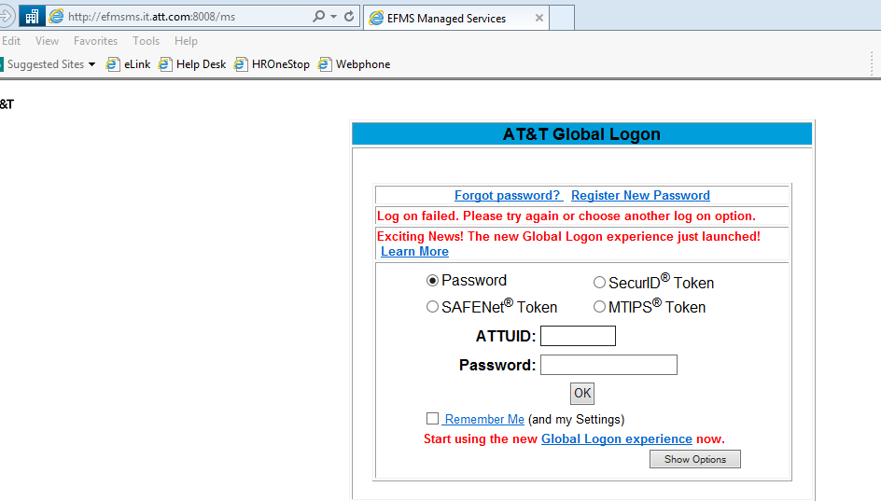

**Step 3:** After entering ATTUID and password in box, press OK button 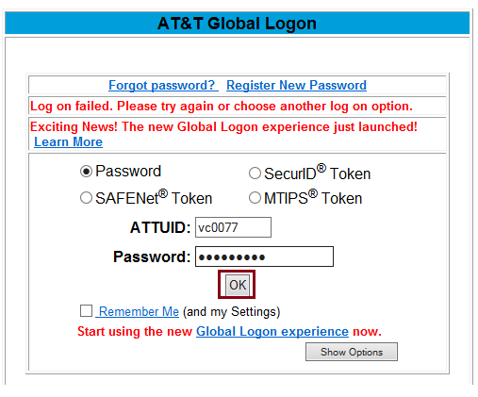

**Step 4:** Front interface of MS GUI will be displayed as shown in below image.

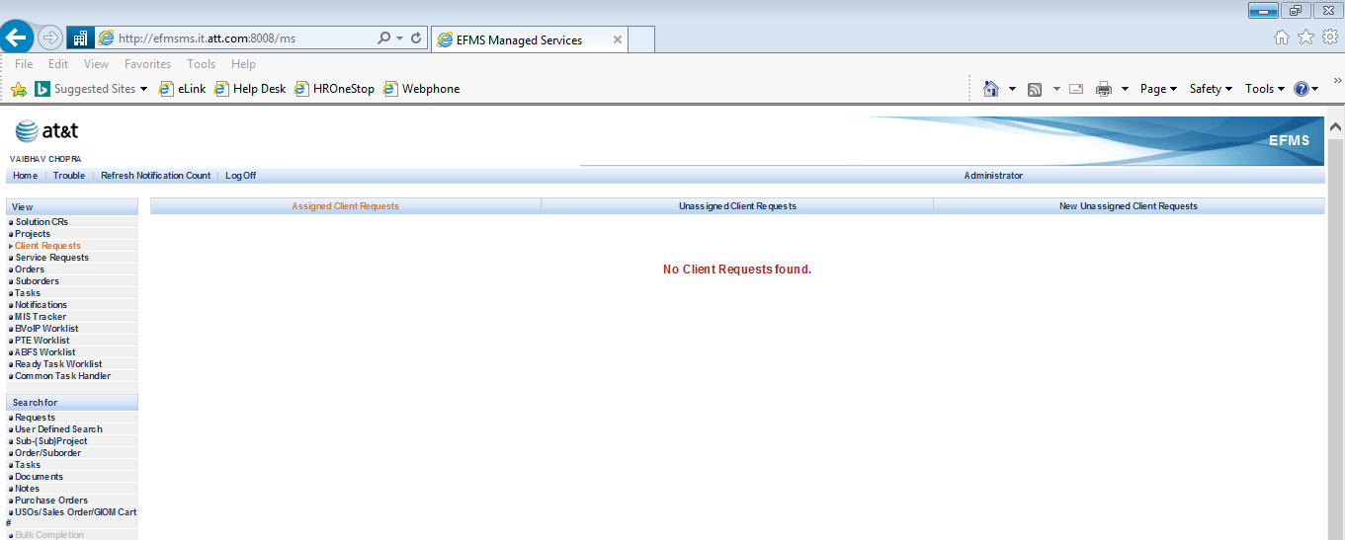

**Step 5:** Click on **User Defined Search**.

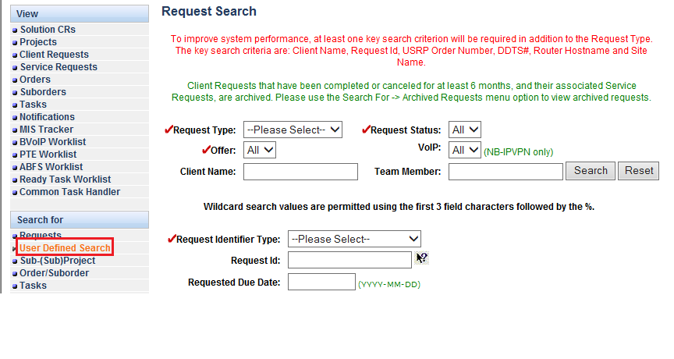

**Step 6:** Click on Request Type option and select **Service Request** option from bar.

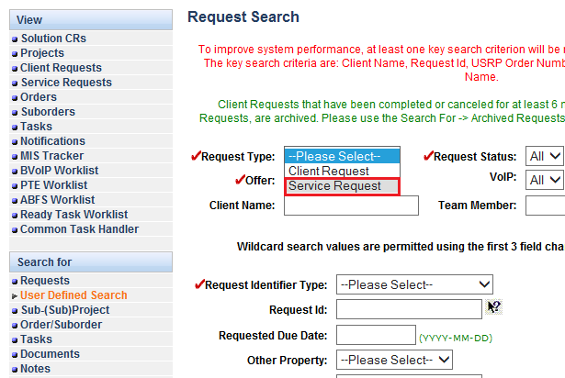

**Step 7:** Write service request ID no. in **Request Id bar**.

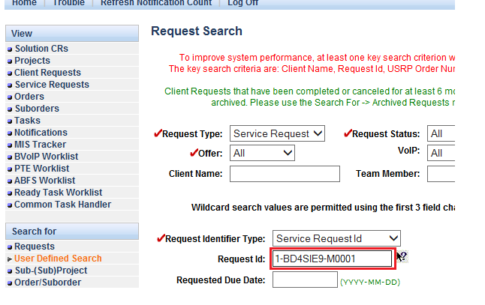

**Step 8**: Click on **Find Requests** tab to open Service request ID.

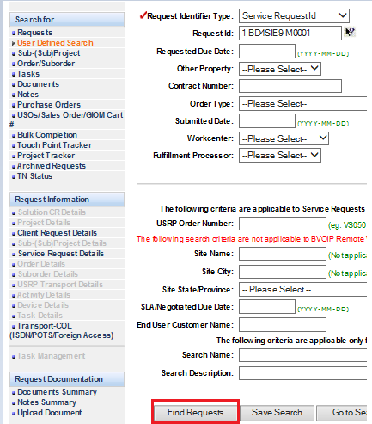

**Step 9:** Service request search results will be displayed, click on **open** tab after tick the box to open service request id.

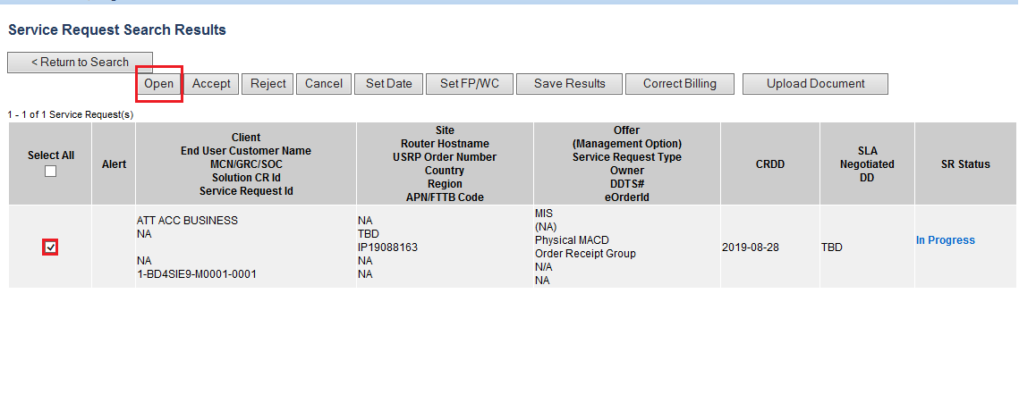

**Step 10:** Service request ID will be displayed with all tabs and information.

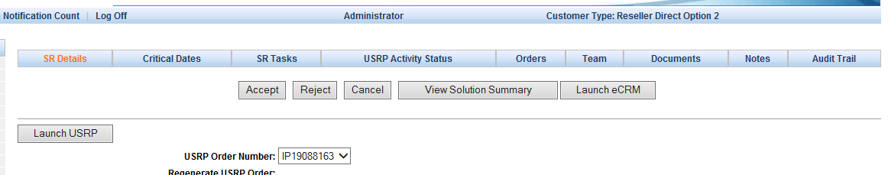

1. **Set EBD (Billing Effective Date ) :**

Run below queries to update the billing effective date in GUI -

* **Find the ms_service_request_id:** Run the following query to get the SR_ID for the update query.

*select ms_service_request_id, sequence_no, status from ms_service_request where ms_client_request_id in (select ms_client_request_id from ms_client_request where solution_number =’ ISR19060320009’);*

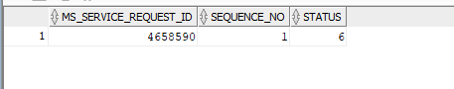

* **Date Format:** Run the following query to check the format for the effective billing date that is to be updated.

*select billing_effective_date from ms_service_request where ms_service_Request_id = ‘4658590’;*

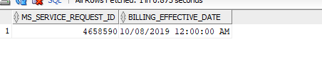

* **Update query:** Run and commit the following query to update the effective billing date for the respective order number.

*update ms_service_Request set Billing_Effective_Date ='07-MAY-14 ' where  
MS_SERVICE_REQUEST_ID =* ‘*4658590’;*